1) Variance = 2.4; Dataset = Blobs; Clusters = 2; Features = 2; bins = 10

5 fold cross Validation Results (Training set size = 16000, Test set size = 4000)

k = 1 Train Error: 0.1711 Test Error: 0.18775

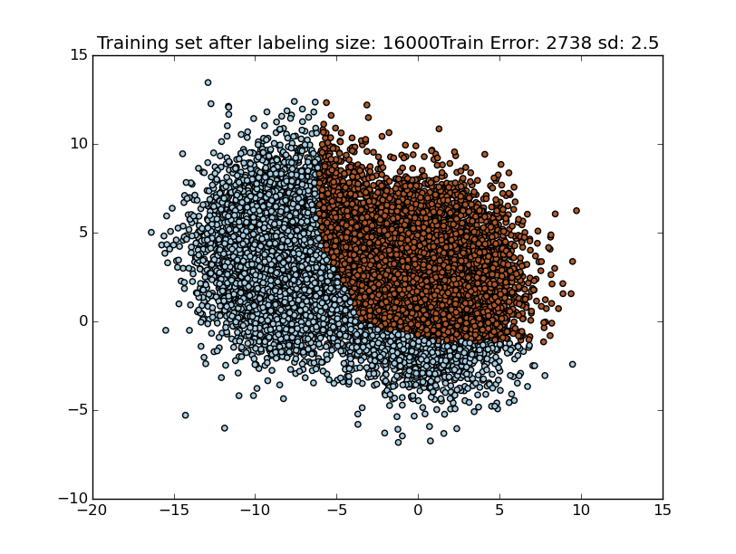

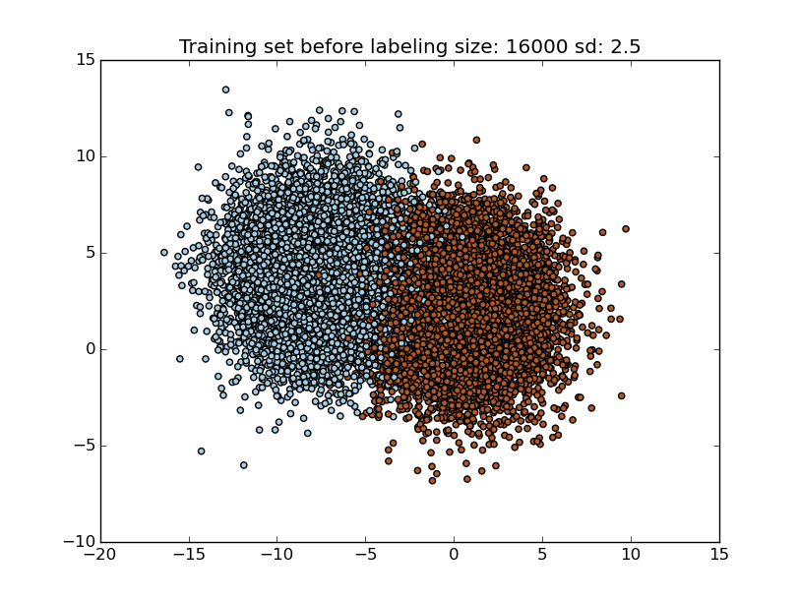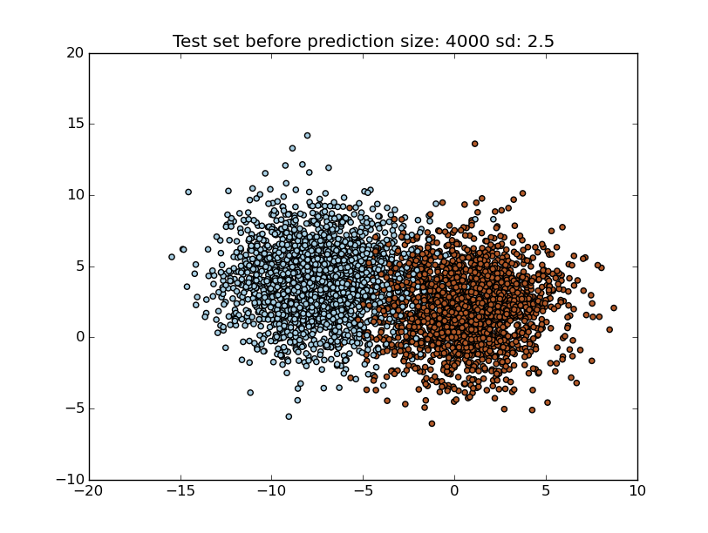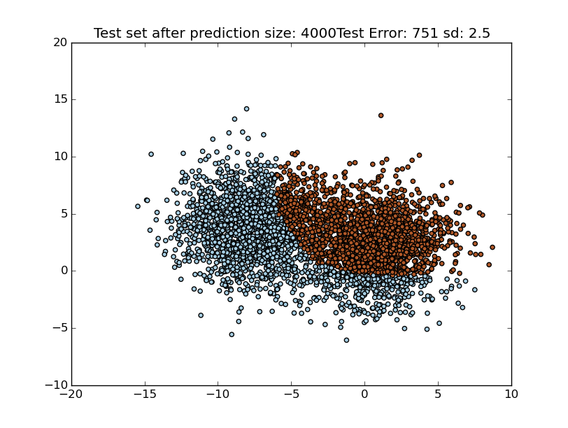

k = 2 Train Error: 0.1086 Test Error: 0.1215

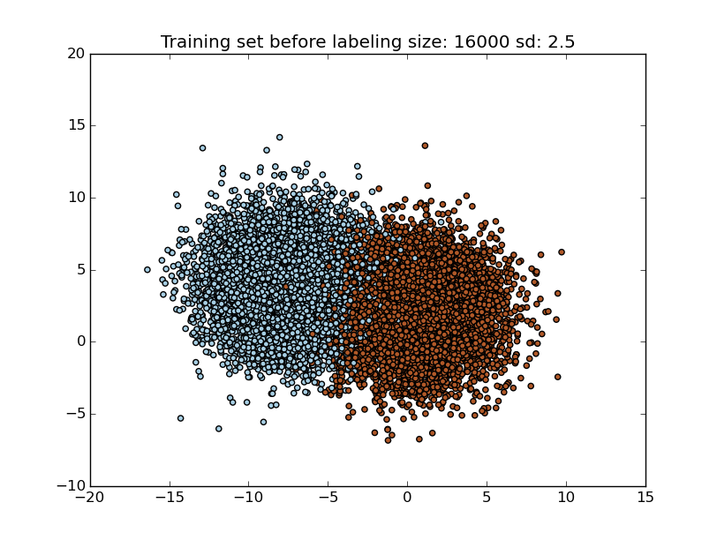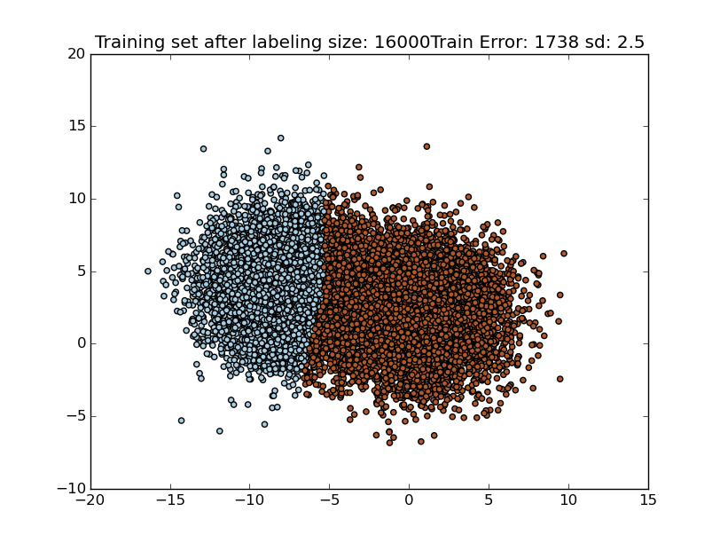

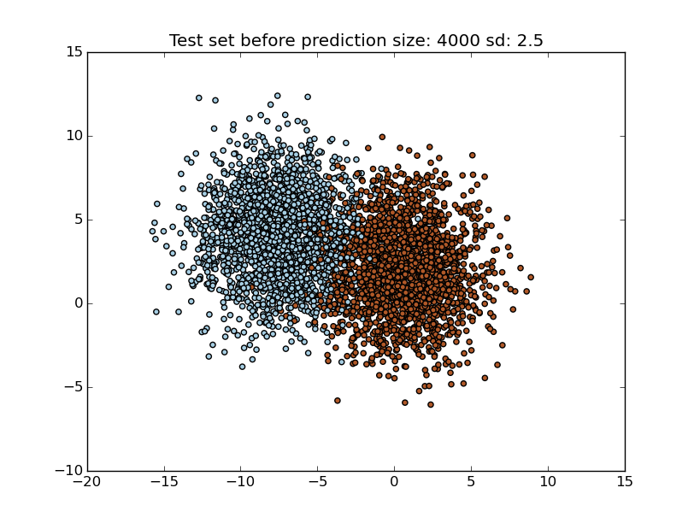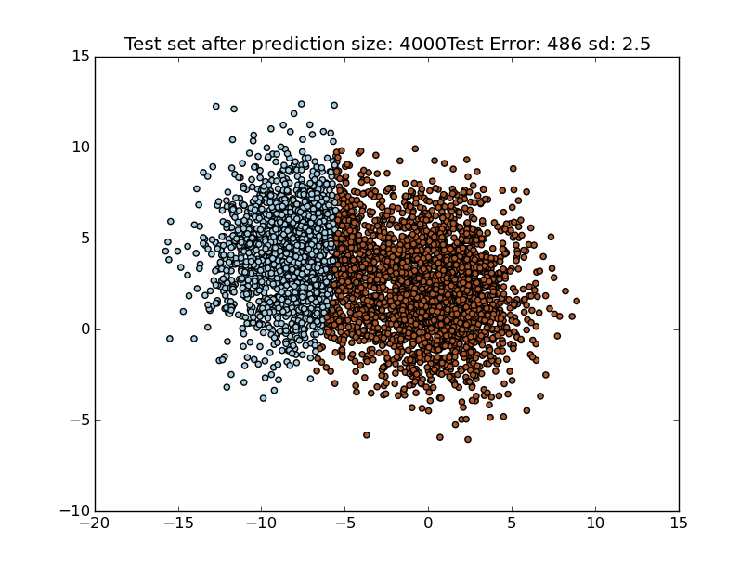k = 3 Train Error: 0.052875 Test Error: 0.0475

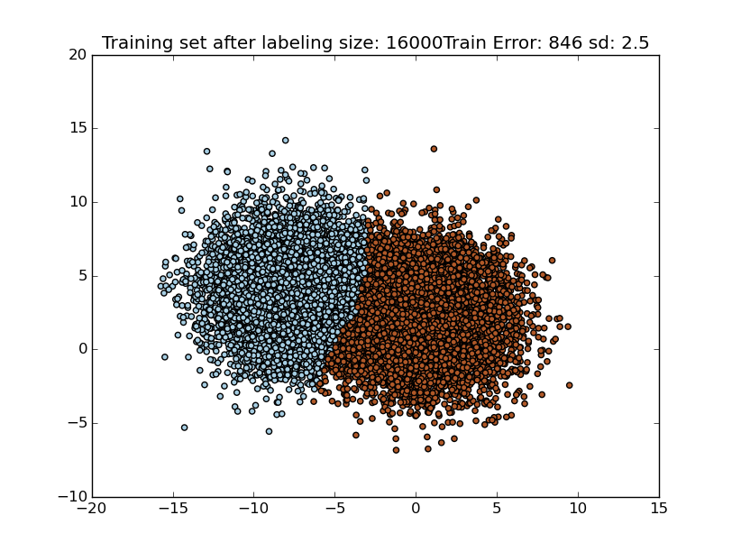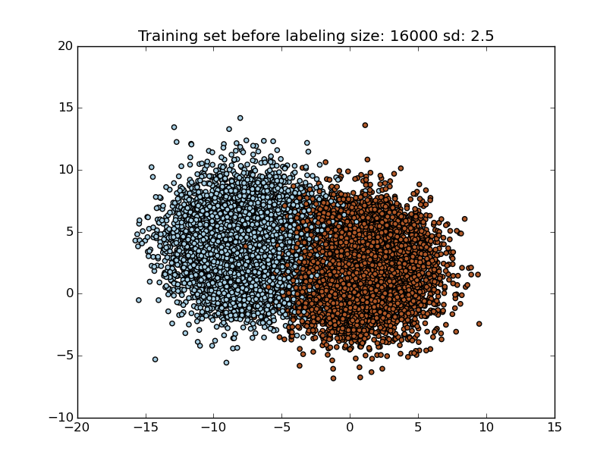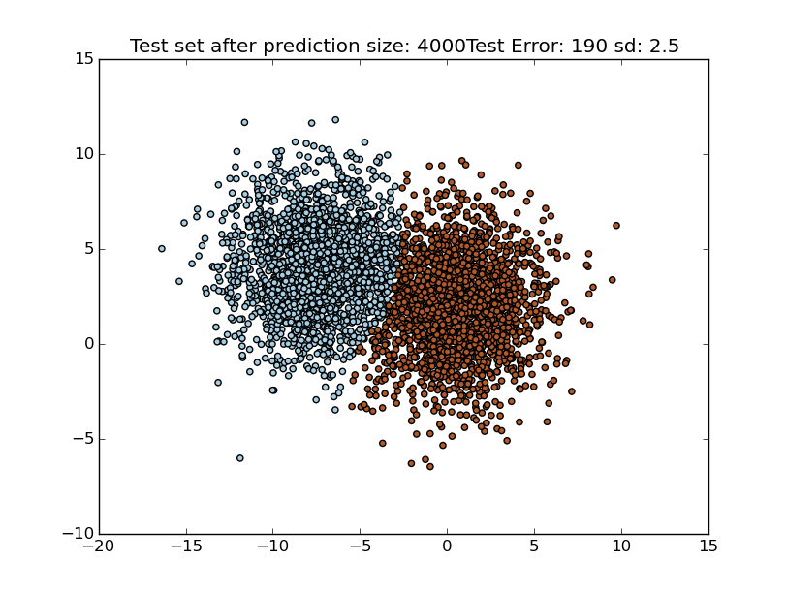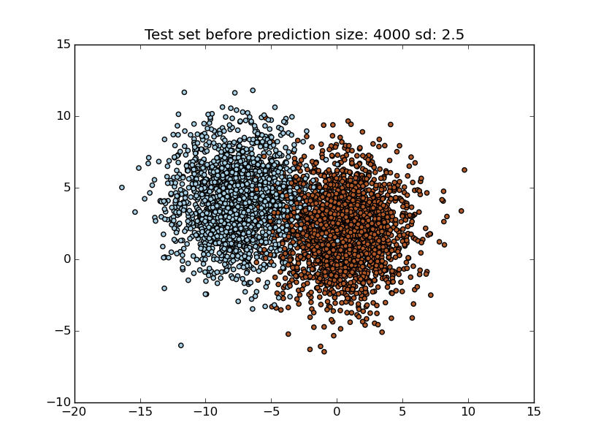

k = 4 Train Error: 0.1149 Test Error: 0.09925

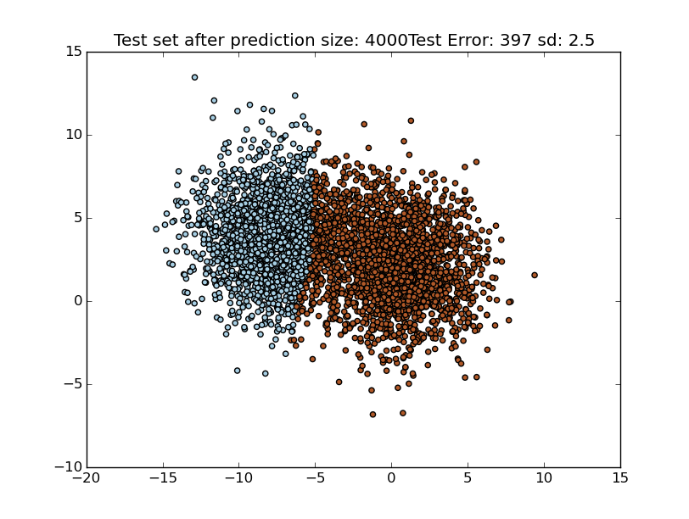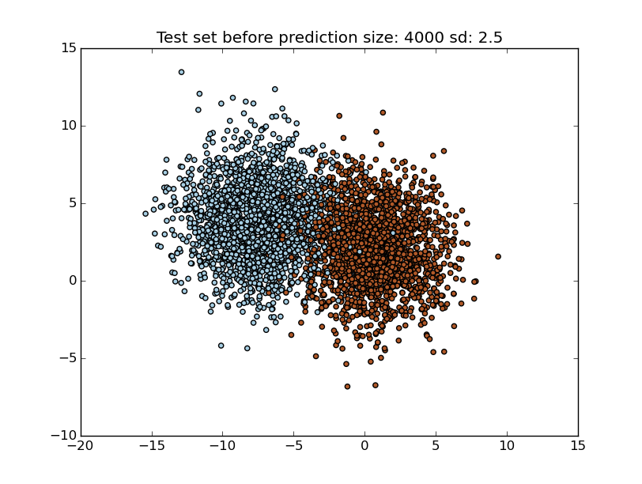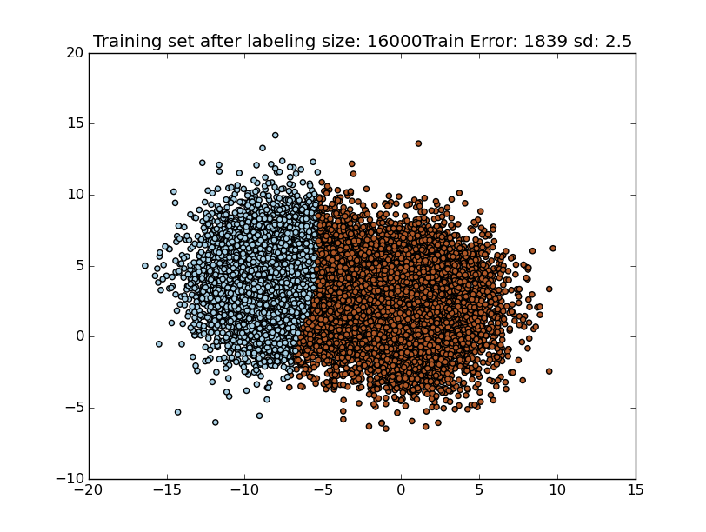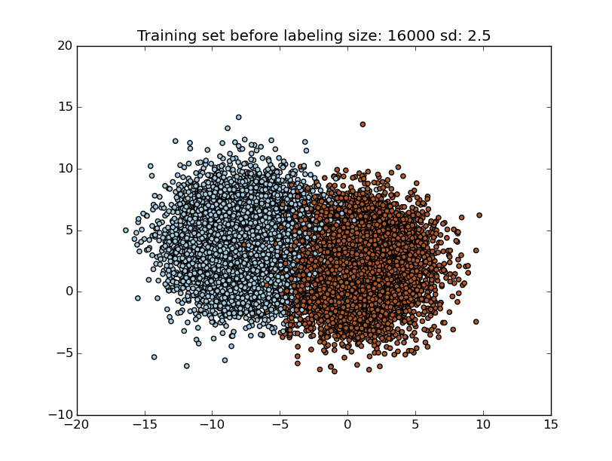

k = 5 Train Error: 0.1306 Test Error: 0.102

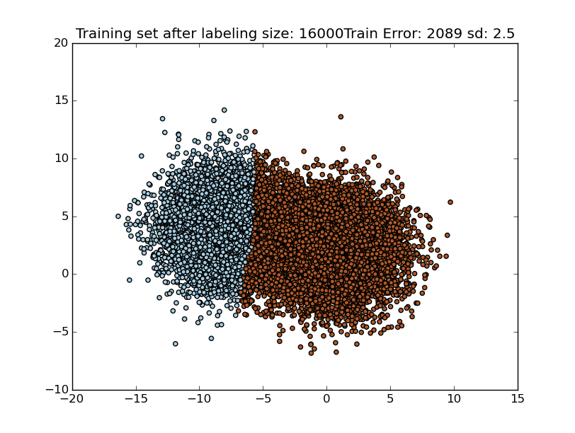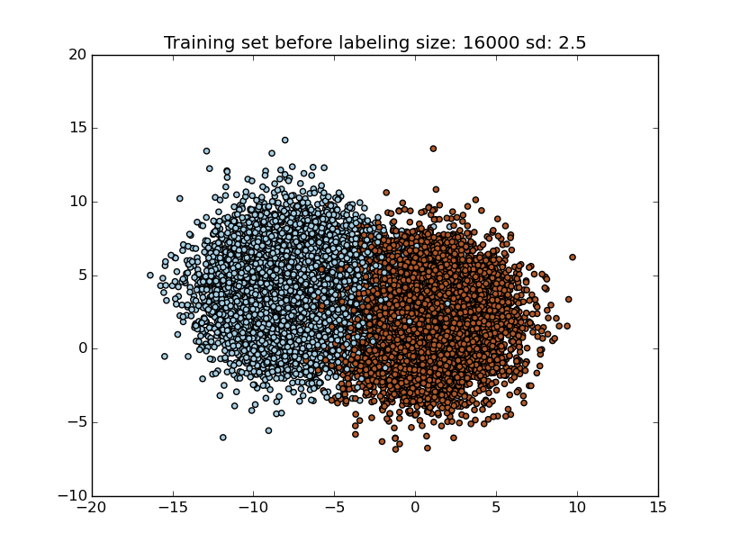2)

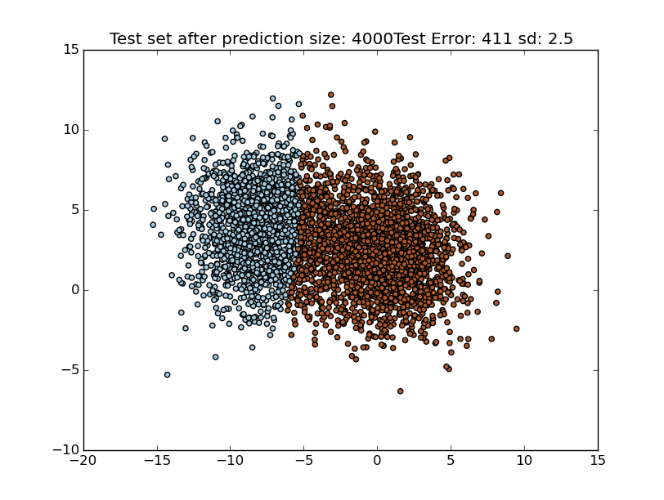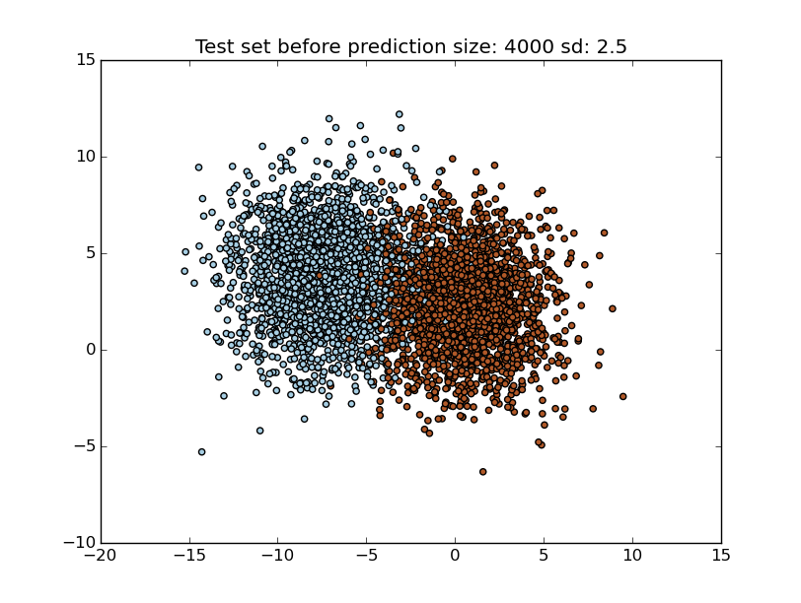

2) Variance = 1.5; Dataset = Blobs(50000); Clusters = 3; Features = 10; bins = 5000

5 fold cross Validation Results (Training set size = 16000, Test set size = 4000)

k = 1 Train Error: Test Error: